Ideation Phase
Brainstorm & Idea Prioritization Template
Project: Auto Ticket Classification using FLOW DESIGNER
Date | 25 September 2026
Team ID | SWTID-2026-4440
Project Name | Auto Ticket Classification using FLOW DESIGNER
Maximum Marks | 4 Marks

Brainstorm & Idea Prioritization Template:
Brainstorming provides a free and open environment that encourages everyone within a team to participate in the creative thinking process that leads to problem solving. Prioritizing volume over value, out-of-the-box ideas are welcome and built upon, and all participants are encouraged to collaborate, helping each other develop a rich amount of creative solutions.
Use this template in your own brainstorming sessions so your team can unleash their imagination and start shaping concepts even if you're not sitting in the same room.
Reference: https://www.mural.co/templates/brainstorm-and-idea-prioritization

Step-1: Team Gathering, Collaboration and Select the Problem Statement
Our topic is Auto Ticket Classification using FLOW DESIGNER. The squad gathered to agree on the problem before generating ideas. The problem was framed as a How Might We statement, and the key rules of brainstorming were fixed up front so that wild ideas were not judged too early.
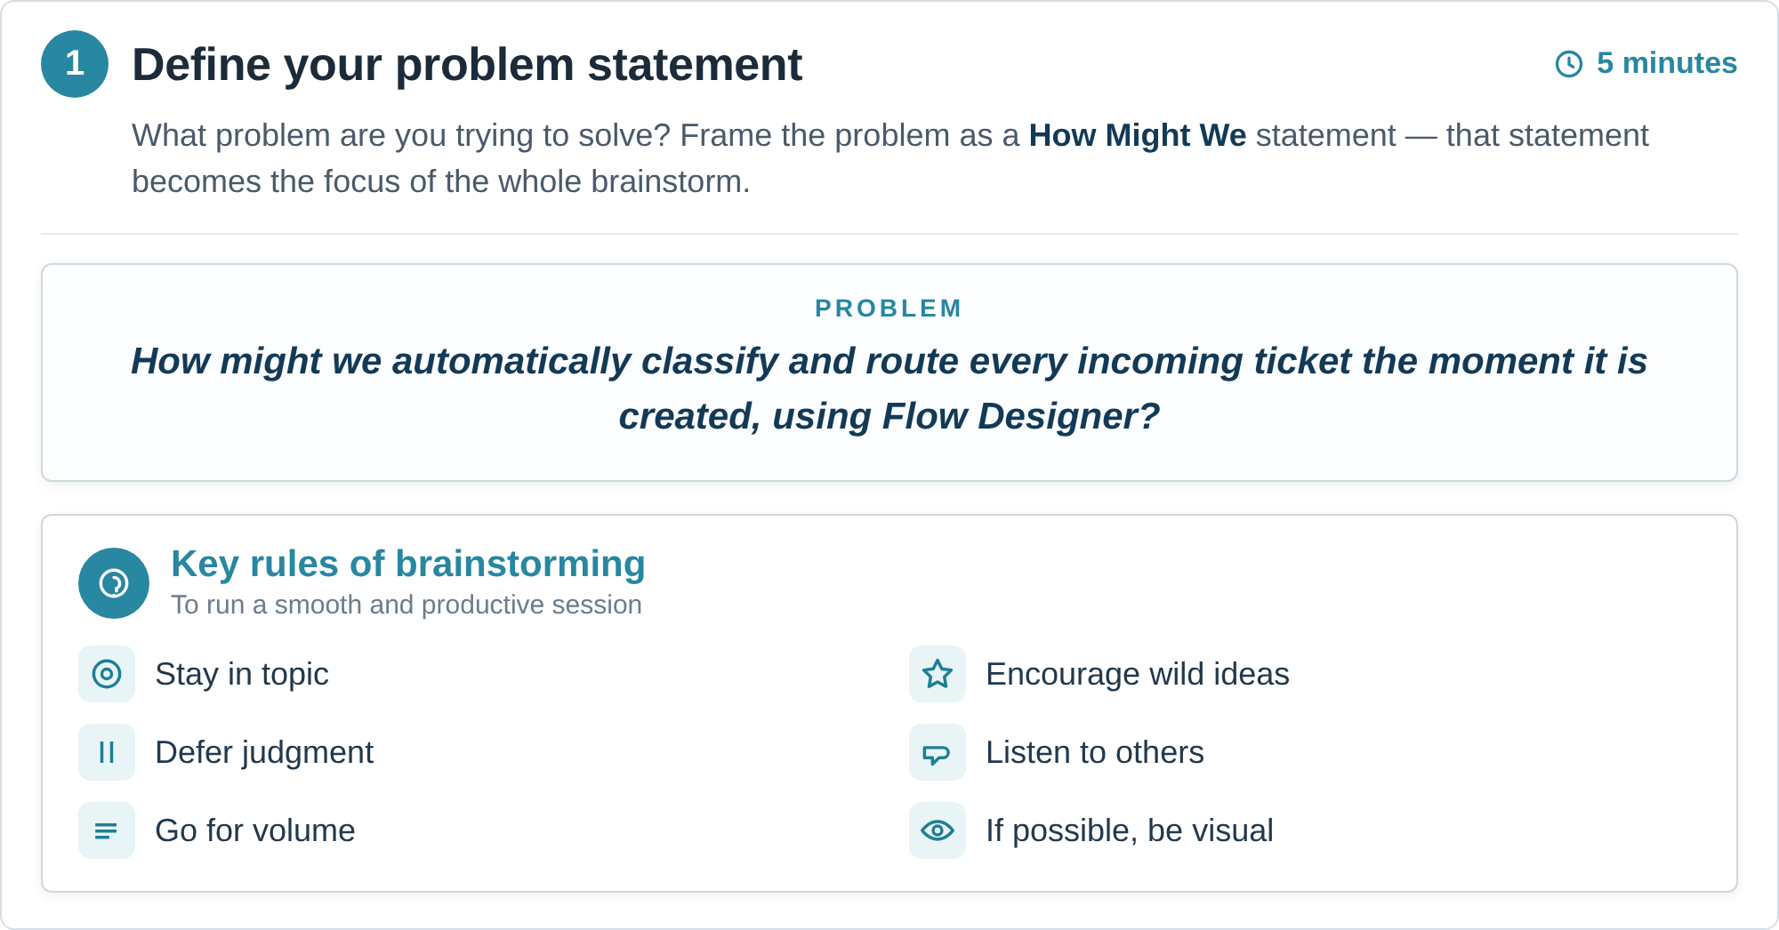
Figure 1 - Step-1 panel: the How Might We problem statement and the key rules of brainstorming.

Step-1: Team Gathering, Collaboration and Problem Statement Selection
The team was assembled, the problem statement agreed, and each participant's contribution recorded against the project. The problem statement below is the one the remainder of this session works on.

Team Member | Role in the Session | Contribution | Focus Area for the Brainstorm
Amar | Facilitator | Ran the session, kept the rules | Intake channels and ticket trigger conditions
Yuktesh | Service Desk Agent (SME) | Brought real triage pain points | Classification logic, category taxonomy and confidence thresholds
Priya | Flow Designer Developer | Assessed build feasibility | Flow actions, rule tables, subflows and reuse
Rahul | ITSM Process Owner | Weighted ideas on business value | Routing, assignment groups, governance and reporting
Meera | Quality Analyst (Observer) | Recorded decisions and risks | Accuracy measurement, audit trail and edge cases

Selected Problem Statement (How Might We)
How might we automatically classify every incoming ticket and route it to the correct assignment group at creation time, so that agents spend their time resolving issues instead of sorting them?
Why this statement: it names a real pain (manual triage), it is bounded to one measurable behaviour (classification and routing at creation), and it is achievable inside ServiceNow without replacing any existing tooling - the only platform capability it depends on is Flow Designer.

Step-2: Brainstorm, Idea Listing and Grouping
With the problem statement fixed, the team generated ideas freely - volume over value. Every idea that could classify a ticket was written down first, and judgement was deferred to Step-3. Fifteen ideas were captured and then clustered into four themes.
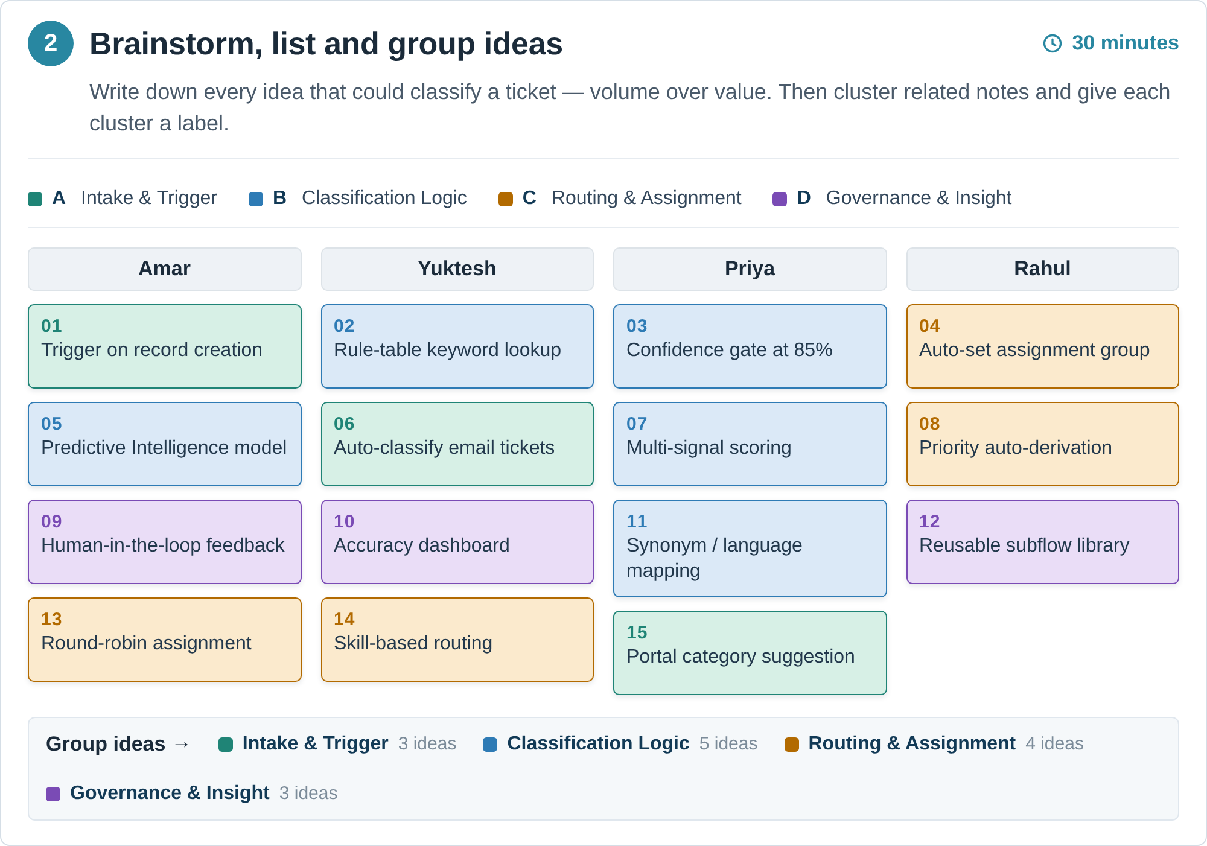
Figure 2 - Step-2 board: the four members' idea cards and the four clusters they were grouped into.
Idea List and Grouping
# | Idea | Cluster | Raised By
1 | Trigger the classification flow the moment a new ticket is created | A | Amar
2 | Maintain a rule table of keywords that maps text to a category | B | Yuktesh
3 | Accept the automatic category only above a confidence threshold | B | Yuktesh
4 | Auto-set the assignment group from the predicted category | C | Amar
5 | Use Predictive Intelligence for the category prediction | B | Yuktesh
6 | Apply the same classification to tickets raised by inbound email | A | Yuktesh
7 | Score several signals (keywords, subject, description, CI) together | B | Priya
8 | Derive priority automatically from category and impact | C | Priya
9 | Let the agent correct the category and feed that back | D | Rahul
10 | Build a dashboard that tracks classification accuracy | D | Rahul
11 | Map synonyms and abbreviations so language variants match | B | Priya
12 | Make the classification logic a reusable subflow | D | Meera
13 | Round-robin tickets inside the resolved assignment group | C | Meera
14 | Route by agent skill and availability | C | Rahul
15 | Suggest a category to the user on the service portal form | A | Amar
Table 1 - The fifteen brainstormed ideas, numbered as on the board in Figure 2.
Clusters
- A - Intake & Trigger - ideas 1, 6, 15: what starts the classification and which channels feed it.
- B - Classification Logic - ideas 2, 3, 5, 7, 11: how a ticket's text is turned into a category and how confident that prediction has to be.
- C - Routing & Assignment - ideas 4, 8, 13, 14: what happens to the ticket once it is classified.
- D - Governance & Insight - ideas 9, 10, 12: feedback, measurement and reuse of the logic.
Step-3: Idea Prioritization
The team placed each idea on an importance versus feasibility grid, then scored the ideas on weighted criteria to produce a defensible ranking. Figure 3 places the ideas; the tables that follow score and rank them.
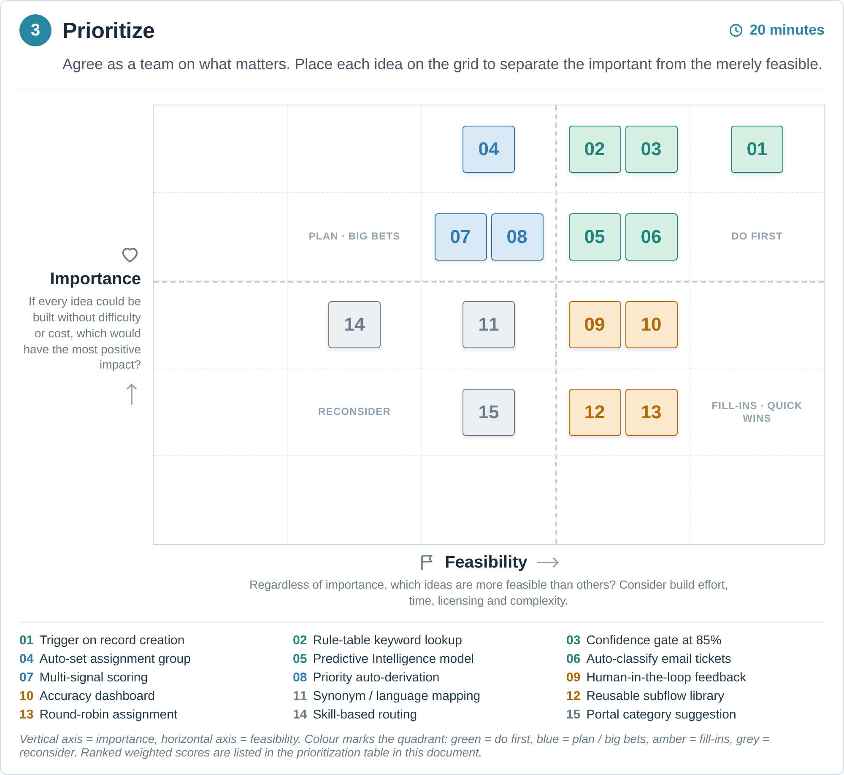
Figure 3 - Step-3 prioritization grid. Vertical axis = importance, horizontal axis = feasibility; each idea is numbered as in Table 1.
Evaluation Criteria and Weights
Criterion | Weight | What it measures | Score Scale
Business impact | 30% | Reduction in manual triage effort and in mis-routed tickets | 1 = low, 5 = high
Build feasibility in Flow Designer | 25% | Can the idea be built with native Flow Designer actions and subflows? | 1 = hard, 5 = easy
Classification accuracy gain | 20% | Expected lift in tickets classified correctly on the first attempt | 1 = low, 5 = high
Implementation effort and time | 15% | Developer days and configuration effort required | 1 = high effort, 5 = low effort
Risk and governance fit | 10% | Audit trail, explainability and compliance of an automated decision | 1 = risky, 5 = safe
Table 2 - The five criteria and the weights agreed by the team.

Prioritization Scoring Table
Every idea was scored 1-5 against the five criteria in Table 2. The weighted score is (Impact x 0.30) + (Feasibility x 0.25) + (Accuracy x 0.20) + (Effort x 0.15) + (Risk x 0.10), out of a maximum of 5.00, and it sets the ranking used to select the scope of the build.

# | Idea | Impact 30% | Feasibility 25% | Accuracy 20% | Effort 15% | Risk 10% | Score | Quadrant / Decision
1 | Trigger the classification flow the moment a new ticket is created | 5 | 5 | 5 | 5 | 4 | 4.90 | DO FIRST - in scope (core build)
2 | Maintain a rule table of keywords that maps text to a category | 5 | 5 | 4 | 4 | 4 | 4.55 | DO FIRST - in scope
3 | Accept the automatic category only above a confidence threshold | 4 | 4 | 5 | 5 | 4 | 4.35 | DO FIRST - in scope
4 | Auto-set the assignment group from the predicted category | 5 | 4 | 4 | 4 | 3 | 4.20 | PLAN / BIG BET - phase 2
5 | Use Predictive Intelligence for the category prediction | 4 | 3 | 5 | 3 | 3 | 3.70 | PLAN / BIG BET - phase 2
6 | Apply the same classification to tickets raised by inbound email | 4 | 5 | 4 | 4 | 3 | 4.15 | PLAN / BIG BET - phase 2
7 | Score several signals (keywords, subject, description, CI) together | 3 | 3 | 4 | 3 | 4 | 3.30 | PLAN / BIG BET - deferred
8 | Derive priority automatically from category and impact | 4 | 4 | 3 | 3 | 3 | 3.55 | PLAN / BIG BET - deferred
9 | Let the agent correct the category and feed that back | 3 | 5 | 4 | 4 | 5 | 4.05 | DO FIRST - in scope
10 | Build a dashboard that tracks classification accuracy | 4 | 4 | 3 | 4 | 5 | 3.90 | FILL-IN - phase 2
11 | Map synonyms and abbreviations so language variants match | 2 | 4 | 3 | 4 | 4 | 3.20 | FILL-IN - deferred
12 | Make the classification logic a reusable subflow | 2 | 4 | 3 | 3 | 5 | 3.15 | FILL-IN - deferred
13 | Round-robin tickets inside the resolved assignment group | 2 | 5 | 2 | 4 | 3 | 3.15 | FILL-IN - deferred
14 | Route by agent skill and availability | 3 | 2 | 2 | 2 | 2 | 2.30 | RECONSIDER - out of scope
15 | Suggest a category to the user on the service portal form | 2 | 4 | 3 | 2 | 3 | 2.80 | RECONSIDER - out of scope
Table 3 - Prioritization scoring. The 15 ideas are listed in number order; the weighted score column is the basis of the ranking in Table 4.

Final Prioritized Backlog
The ideas are ranked by weighted score. The top rows define what the project builds first; everything below is explicitly deferred, not dropped.

Rank | # | Idea | Score | Decision
1 | 1 | Trigger the classification flow the moment a new ticket is created | 4.90 | Build first
2 | 2 | Maintain a rule table of keywords that maps text to a category | 4.55 | Build first
3 | 3 | Accept the automatic category only above a confidence threshold | 4.35 | Build first
4 | 4 | Auto-set the assignment group from the predicted category | 4.20 | Phase 2
5 | 6 | Apply the same classification to tickets raised by inbound email | 4.15 | Phase 2
6 | 9 | Let the agent correct the category and feed that back | 4.05 | Build first
7 | 10 | Build a dashboard that tracks classification accuracy | 3.90 | Phase 2
8 | 5 | Use Predictive Intelligence for the category prediction | 3.70 | Phase 2
9 | 8 | Derive priority automatically from category and impact | 3.55 | Deferred
10 | 7 | Score several signals (keywords, subject, description, CI) together | 3.30 | Deferred
11 | 11 | Map synonyms and abbreviations so language variants match | 3.20 | Deferred
12 | 12 | Make the classification logic a reusable subflow | 3.15 | Deferred
13 | 13 | Round-robin tickets inside the resolved assignment group | 3.15 | Deferred
14 | 15 | Suggest a category to the user on the service portal form | 2.80 | Out of scope
15 | 14 | Route by agent skill and availability | 2.30 | Out of scope
Table 4 - Final prioritized backlog for Auto Ticket Classification using FLOW DESIGNER.
Selected Scope (Top 4 Ideas)
The following four ideas are taken forward into the build because they sit in the do-first quadrant on the grid and rank highest on the weighted score:
1. Trigger - Trigger the classification flow the moment a new ticket is created (idea 1).
2. Rule table - Maintain a rule table of keywords that maps text to a category (idea 2).
3. Confidence gate - Accept the automatic category only above a confidence threshold (idea 3).
4. Feedback loop - Let the agent correct the category and feed that back (idea 9).
Idea 5 - Flow Designer Implementation
Idea 5, the Predictive Intelligence path, is planned for phase 2. Until a model is trained, the same prediction step is satisfied by the keyword rule table from idea 2, so the flow designed now does not have to change shape when the model arrives. The figure below shows the end-to-end flow that the four selected ideas produce.
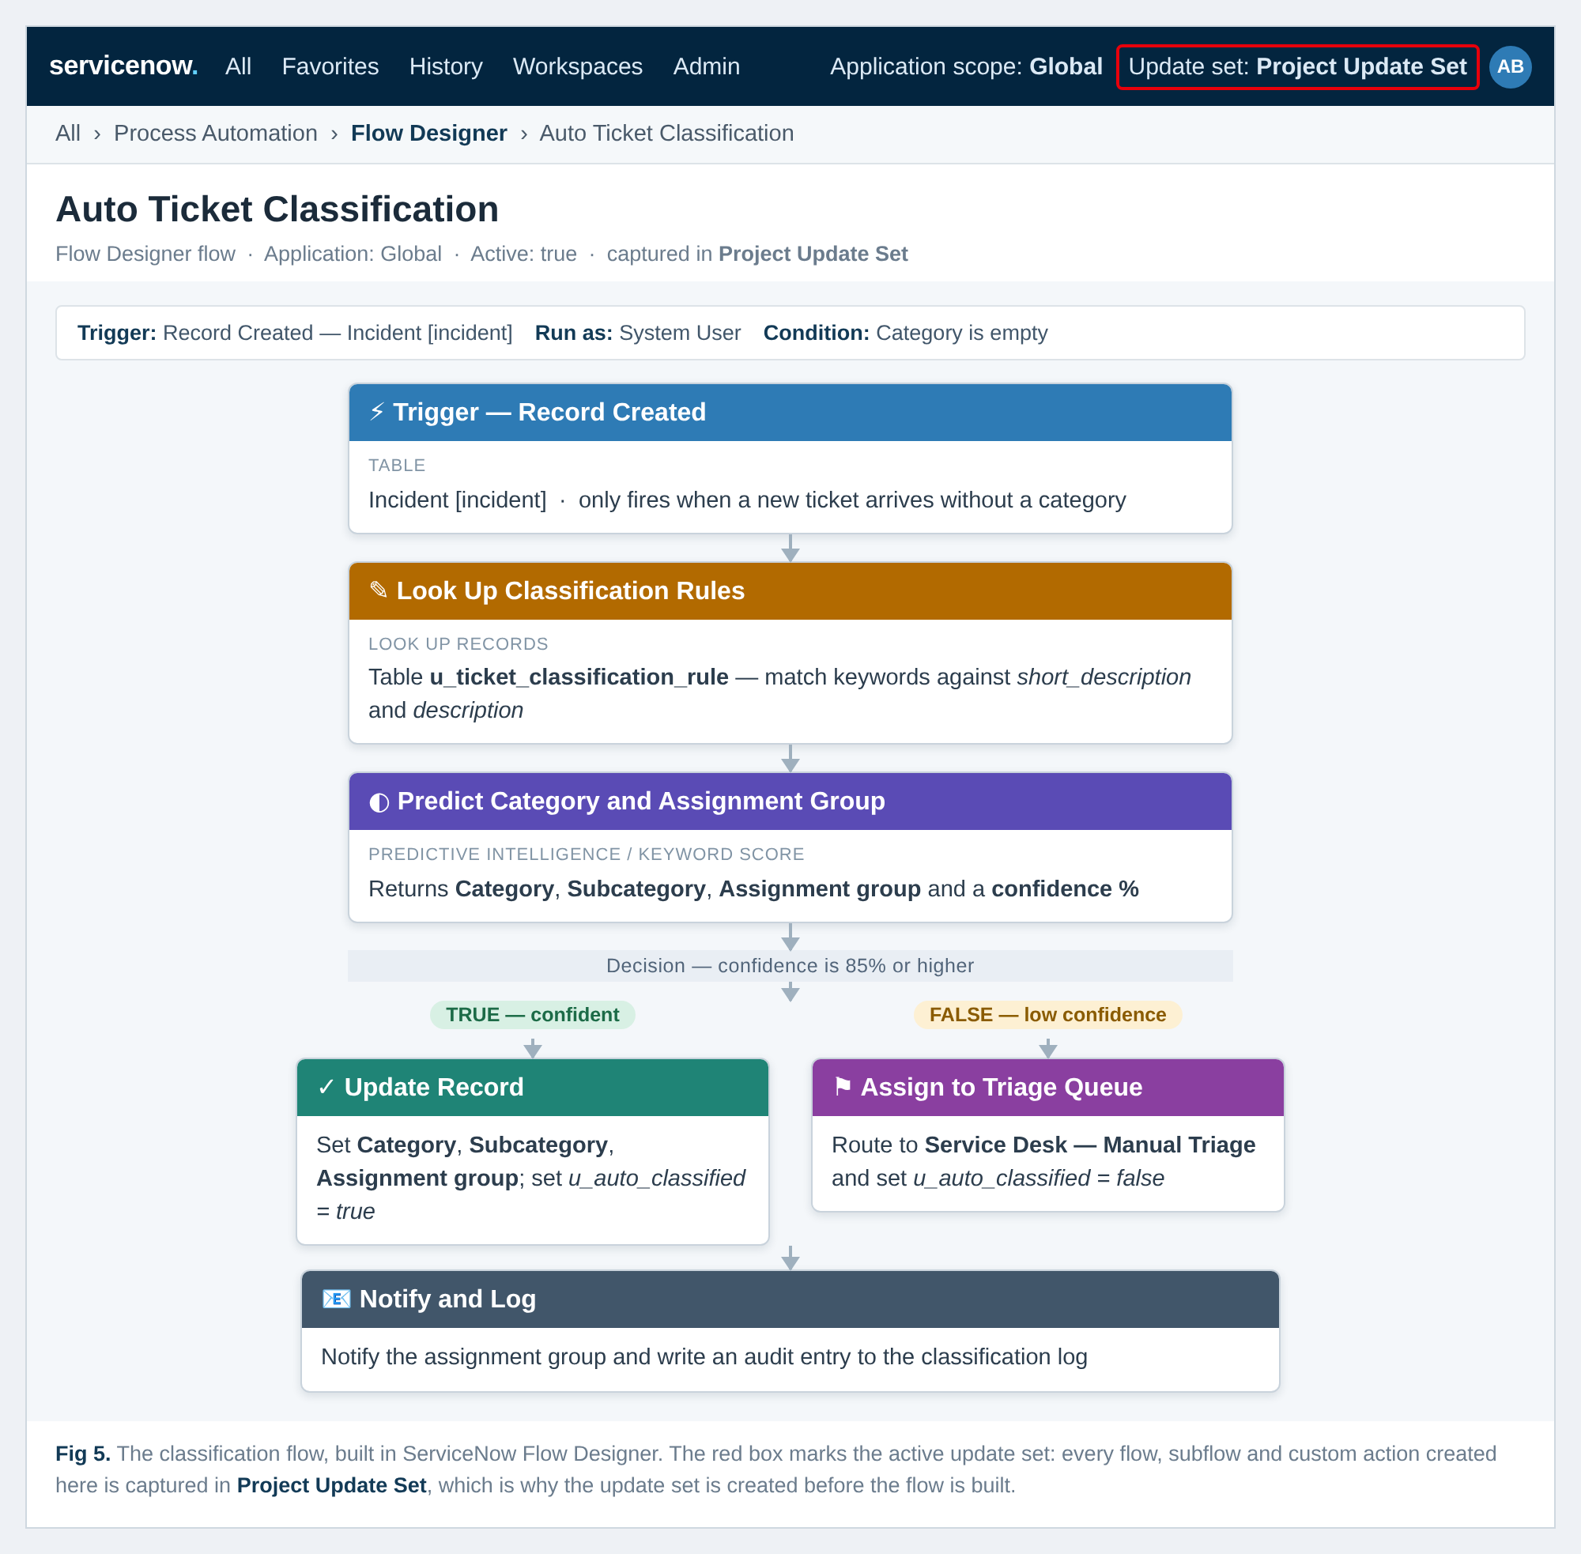
Figure 4 - The classification flow as built in ServiceNow Flow Designer (trigger, rule lookup, prediction, confidence decision, update or triage, notify and log).
ServiceNow Configuration - Create the Update Set
Before the flow is built, a local update set must be created and made current, so that the flow, its subflows and its custom actions are captured and can be promoted to the test and production instances. The screenshot below follows the two reference images supplied with this session.
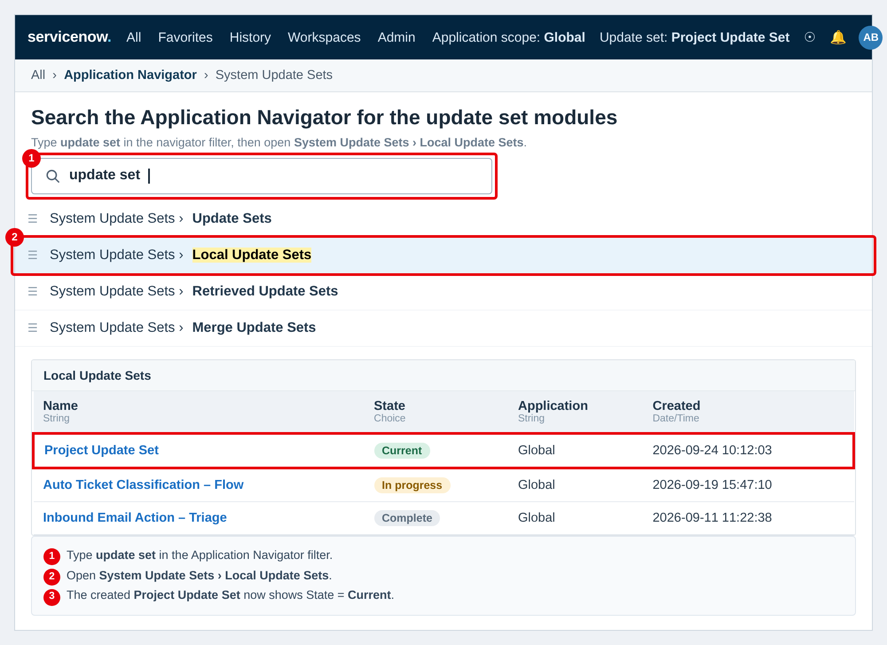
Figure 5 - Finding the update set modules in the Application Navigator (steps 1 and 2).
1. Go to All menus → Search for "Update set"
2. Under System Update Sets → Select Local Update Sets
3. Click the New button on the top right corner of the page
4. Name: Project Update Set
5. State: In progress
6. Application: Global
7. Then Save the Form
8. Under Related links, click on "Make This My Current Set"
9. Then the created Update Set will appear as Current
With the update set marked Current, every configuration created for Auto Ticket Classification - the flow, the rule table, the custom actions and the notification - is recorded against Project Update Set, which is what allows the work to be moved between instances.
Summary and Next Steps
Fifteen ideas were generated against a single How Might We problem statement, grouped into four themes, and ranked with a weighted five-criterion model. Four ideas were selected for the build, and the Project Update Set was created and made current so that the Flow Designer work is captured from the first click.
1. Build the keyword rule table and the classification flow inside the current update set.
2. Add the confidence gate at 85% and route anything below it to the manual triage queue.
3. Instrument the accuracy dashboard (idea 10) so the 85% threshold can be tuned with evidence.
4. Train the Predictive Intelligence model as phase 2 and swap it into the existing prediction step.

